**INGLÊS II – BANCO DE DADOS**

Class Didactic Material

Profa. Teresinha de Fátima Nogueira

**Class 1 - Content: Everyday activities and routine**

I – Objective: Talking about everyday activities and routine

# Warm up - Oasis - Wonderwall - <https://www.youtube.com/watch?v=sYffFEIAzdE>

Problem 1: At job interviews it is common that interviewers ask you what you do at work all day. So, to practice this sort of situation, prepare a presentation talking about your everyday activities at work. (2,0 pontos)

To help you to solve the problem, we present the activities in two parts: the first about personal routine and the second about professional routine. You can do the activities that follow or choose your own way.

A – Personal daily activities:

1– Watching a video and improving vocabulary: watch the following video to learn vocabulary about daily routine.

<https://www.youtube.com/watch?v=ecF1y2bI2T4&t=315s>

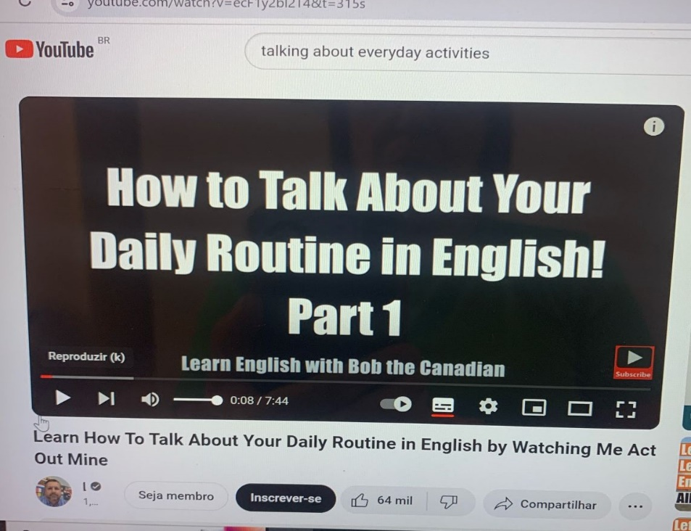

* 1. – Vocabulary exercises:

Match the words on the left with their corresponding definitions on the right.

1 – Wake up ( 3 ) The activities you do regularly

2 – Breakfast ( 4 ) The time when you go to bed

3 – Routine ( 2 ) The first meal of the day

4 – Bedtime ( 1 ) The time when you start your day

5 – Activities ( 5 ) The thing you do before you sleep at night

1.2 – You can also improve your vocabulary by watching the following video:

<https://www.youtube.com/watch?v=hzzc1VSwuIg>

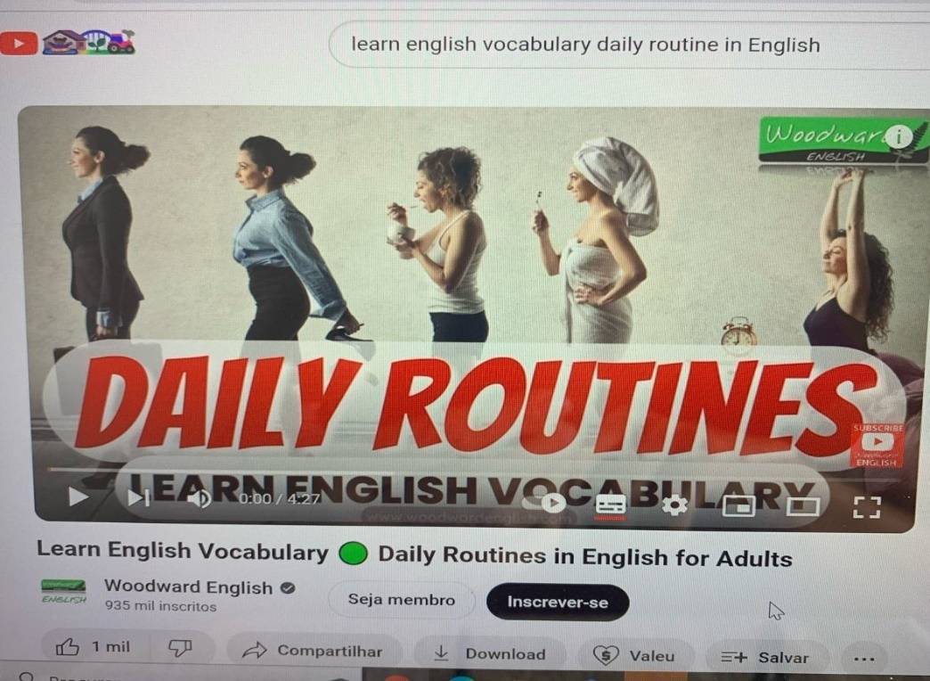

* 1. – Prepare a short paragraph talking about your daily routine.

________________________________________________________________________________________________________________________________________________________________________________________________________________________________________________________________________________________

______________________________________________________________________

**Class 2 - Content: Everyday activities and routine**

I – Objective: Talking about everyday activities and routine

# Warm up - Green Day - Time of Your Life (Good Riddance) - <https://www.youtube.com/watch?v=fhrK0i-2Nes>



(from [https://www.pexels.com/search/people%20talking/](https://www.pexels.com/search/people talking/))

2 – Speaking: Ask and answer these questions:

1-What time do you get up?

2-Do you have breakfast in the morning? What do you have for breakfast?

3-How do you go to work or school?

4-What time do you start work or school?

5-What do you do in the morning?

6-Do you have lunch at home?

7-What do you normally have for lunch?

8-What do you do in the afternoon?

9-What do you do after work or school?

10-Do you relax in the evening? What do you do?

11-What time do you go to bed?

12-When do you check your social media?

13-How many hours are you online every day?

14-What activities do you like to do?

15-What good habits do you have?

16-What do you do in your free time?

17-Do you think it is important to have a daily routine? Why or why not?

18-Do you plan what you do each day? Why or why not?

19-How do you organize your study time?

20-What do you want to change in your daily routine? Why?

B – Professional daily activities:

3 – Reading and vocabulary: Read a passage about a person talking about his/her routine at work and check understanding with your teacher or another student.

3.1 - I’m a live music promoter. I work for a small company in Sydney. We find new bands and promote them – we sell tickets, print posters, book the venues - things like that.

My typical working day is pretty long. First of all I arrive at the office early – around eight or eight-thirty. Then I check my e-mails. I usually have a lot of messages from bands and booking agencies. Next, I talk to the management team to check the program of events. After that, I usually have meetings. I spend the afternoon meeting clients – sometimes two or three meetings a day. Finally, in the evenings, I watch the bands perform, or I go looking for new acts. I really like my job. It’s very interesting and I meet lots of different people.

(from Business Venture 1, by Roger Barnard et al, OUP).

**Class 3 - Content: Everyday activities and routine**

I – Objective: Talking about everyday activities and routine at work.

Warm up - Maroon 5 - She will be loved - <https://www.youtube.com/watch?v=Towlyz-3vYA>



(from <https://www.gettyimages.com.br/detail/foto/teen-girls-debates-with-peers-in-class-imagem-royalty-free>)

4 – Speaking: Ask and answer these questions about work routine:

1-What is the first thing you do when you arrive work?

2-How many times a day do you send work messages?

3-What motivates you at your work?

4-What qualities does your boss have?

5-What qualities are necessary to do your job?

6-Do you socialize with your work colleagues outside work? Why? Why not?

7-Does your company use a flexible time system? Why? Why not?

8-What is the atmosphere like at your workplace?

9-What things do you do at work that are related to the subjects you study at faculty?

10-How often does your boss ask for you to work overtime?

11-What career goals do you have?

12- How has technology changed business? Do you think it's created more work or less?

13- Would you prefer to have an easy routine job or a job in which you made a lot of decisions? Why?

14- What three things are most important for you in a job? Why?

15- Would you like a job that involved a lot of travel? Why or why not?

16- If you could own your own business, what would it be?

**Class 4 - Content: Everyday activities and routine**

I – Objective: Talking about everyday activities and routine at work.

Warm up – song: U2 - With or Without You –<https://www.youtube.com/watch?v=WZKnQRkWzLI>

5 – Language structure needed: Simple present tense. To understand how you use and form the simple present tense, you can watch the following video, search for another video on the Internet or interact with the teacher’s explanation that follows.

<https://www.youtube.com/watch?v=-h_LSiGy1Yc> (video about the present tense)

**SIMPLE PRESENT TENSE**

|  |  |  |
| --- | --- | --- |
| POSITIVE SENTENCES | | |
| SUBJECT | VERB | COMPLEMENT |
| I  You  We  They | WORK | in a big company. |
| He  She  It | WORKS | very well. |

|  |  |  |  |
| --- | --- | --- | --- |
| INTERROGATIVE SENTENCES | | | |
| AUXILIAR VERB | SUBJECT | VERB | COMPLEMENT |
| DO | I  You  We  They | work | in a big company? |
| DOES | He  She  It | work | very well? |

|  |  |  |  |
| --- | --- | --- | --- |
| NEGATIVE SENTENCES | | | |
| SUBJECT | AUXILIAR VERB + NOT | VERB | COMPLEMENT |
| I  You  We  They | DO NOT / DON’T | work | in a big company. |
| He  She  It | DOES NOT / DOESN’T | work | very well. |

|  |  |
| --- | --- |
| VERBS FOR HE / SHE / IT | |
| SPELLING RULES | EXAMPLES |
| With most verbs, add “S” | live – liveS  stay - stayS |
| Ending in consonant + “Y”, change “Y” to “I” and add “ES” | try – trIES  carry - carrIES |
| Ending in “S”, “Z”, “CH”, “SH”, “X”, “O”, add “ES” | miss – missES  catch - catchES |

5.1 – Exercises: Do these online exercises.

<https://www.englisch-hilfen.de/en/exercises/tenses/simple_present_mix.htm>

<http://www.english-room.com/grammar/presentsimpletense_affirmative_1.htm>

<https://www.perfect-english-grammar.com/present-simple-exercise-7.html>

<https://www.grammarbank.com/simple-present-tense-exercise-2.html>

**Class 5 - Content: Everyday activities and routine**

I – Objective: Talking about everyday activities and routine at work.

6 – Speaking: Prepare the oral presentation suggested in problem 1 about your everyday activities at work.



(from <https://unsplash.com/pt-br/fotografias/tres-pessoas-sentadas-em-frente-a-mesa-rindo-juntas-g1Kr4Ozfoac>)

**Class 6 - Content: Everyday activities and routine**

I – Objective: Talking about everyday activities and routine at work.

7 – Oral presentation: Presentation of the activity suggested in problem 1 about your everyday activities at work. (2.0 pontos)



(from <https://www.freepik.com/free-photos-vectors/student-presentation>)